Phase 2 — Development & Implementation
FitHub CRM
Fitness Center Management System — Development Phase Document
Sections  12 | Custom Objects  4 | Automations  Flow | Platform  Salesforce

01 Introduction

What is the Development Phase?
The development phase is where project plans are transformed into a working system. It encompasses environment configuration, object creation, automation, UI setup, and testing — covering the full lifecycle of implementation.

For the FitHub CRM project, the development phase involves building a fully functional Salesforce-based fitness center management system. This phase directly implements the scope defined in the planning document, translating requirements into configured objects, relationships, workflows, reports, and dashboards.
Implementing the system correctly is critical because it determines the accuracy of data, the reliability of automation, and the usability of the interface. A well-executed development phase results in a system that genuinely solves operational challenges — eliminating manual effort, reducing errors, and providing actionable management insights.

02 Environment Setup

Salesforce Developer Org  Registered at developer.salesforce.com  Free Developer Edition with full CRM capabilities  Sandbox environment for safe configuration & testing | App Creation  New Lightning App created: FitHub CRM  Custom app icon and branding applied  Configured as a Lightning Experience app | Navigation Setup  Custom tabs added: Members, Trainers, Classes, Bookings  Navigation bar configured in App Manager  App Launcher shortcut enabled for quick access

The Salesforce Developer Edition provides a complete CRM environment at no cost, making it ideal for academic projects. The FitHub CRM Lightning App consolidates all four custom objects under a single navigation bar, giving users a focused, professional interface that mirrors a real-world deployment.

03 Custom Object Creation

Four custom Salesforce objects were created to model the core entities of a fitness center. Each object represents a real-world concept and contains fields appropriate to its purpose.

3.1 Member Object
The Member object stores all information about individuals who have enrolled in the fitness center. It is the central entity of the CRM, linked to Bookings for class reservations.
Field Name | Data Type | Required | Description
Member Name | Text (Auto Name) | Yes | Unique identifier for the member record
Email | Email | Yes | Member contact email address
Phone | Phone | No | Member contact phone number
Membership Type | Picklist | Yes | Basic / Standard / Premium tier
Status | Picklist | Yes | Active / Inactive / Suspended
Start Date | Date | No | Membership commencement date
End Date | Date | No | Membership expiry date

Screenshot 1 — New Member Record Creation
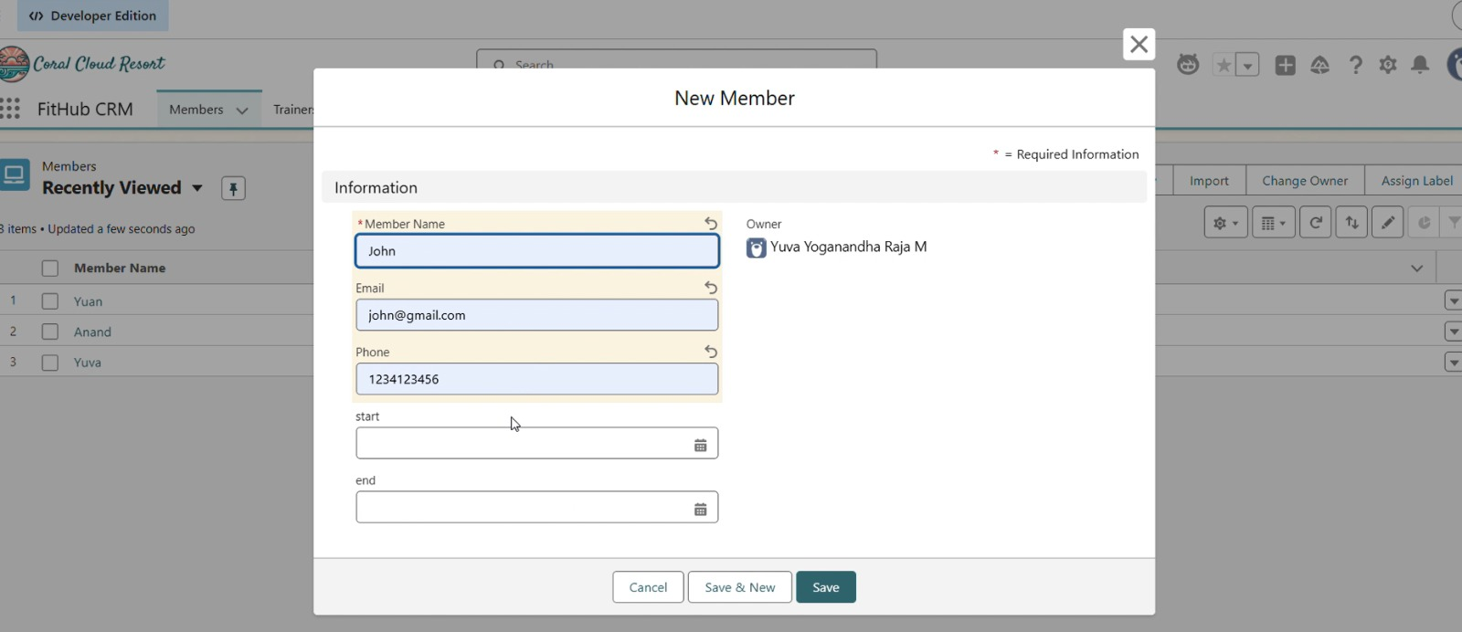
FitHub CRM: New Member form showing Member Name, Email, Phone, Start and End Date fields with sample data entered for member 'John'

3.2 Trainer Object
The Trainer object stores details about fitness instructors who are assigned to classes. Each trainer is linked to one or more Class records through a lookup relationship.
Field Name | Data Type | Required | Description
Trainer Name | Text (Auto Name) | Yes | Unique identifier for the trainer
Specialty | Text | Yes | Area of expertise (e.g., Yoga, HIIT)
Experience (Years) | Number | No | Years of professional experience
Email | Email | No | Trainer contact email
Status | Picklist | No | Active / On Leave / Inactive

3.3 Class Object
The Class object represents individual fitness sessions offered by the center. Each class is associated with a trainer and can have multiple bookings made by members.
Field Name | Data Type | Required | Description
Class Name | Text (Auto Name) | Yes | Name/type of the fitness class
Schedule | DateTime | Yes | Date and time the class takes place
Capacity | Number | No | Maximum number of members allowed
Trainer | Lookup (Trainer) | Yes | Links class to its assigned trainer
Status | Picklist | No | Scheduled / Completed / Cancelled

3.4 Booking Object
The Booking object records a member's reservation for a specific class. It serves as the junction between the Member and Class objects and is the primary trigger point for automation.
Field Name | Data Type | Required | Description
Booking Name | Text (Auto Name) | Yes | Auto-generated booking reference
Member | Lookup (Member) | Yes | Member who made the booking
Class | Lookup (Class) | Yes | Class the member booked
Booking Date | Date | Yes | Date on which booking was made
Status | Picklist | Yes | Confirmed / Pending / Cancelled

04 Relationship Setup

Object relationships in Salesforce define how records are connected and how data flows between them. Correct relationship design ensures data integrity and enables efficient querying and reporting.

Trainer → Class | One-to-Many (Lookup) | One trainer can be assigned to multiple classes. The Class object holds a Lookup field pointing to a Trainer record.
Class → Booking | One-to-Many (Lookup) | One class can have multiple bookings. The Booking object holds a Lookup field pointing to the Class record.
Member → Booking | One-to-Many (Lookup) | One member can make multiple bookings. The Booking object holds a Lookup field pointing to the Member record.

05 Field Customization & Validation

Field customization ensures that the data entered into the system is consistent, meaningful, and error-free. Salesforce provides picklists, required field markers, and declarative validation rules to enforce data quality without writing code.

Picklist: Status | Applied to Member, Class, and Booking objects. Restricts status entry to predefined values: Active, Inactive, Confirmed, Pending, Cancelled.
Picklist: Membership Type | Applied to the Member object with values Basic, Standard, and Premium for tier-based member classification.
Required Fields | Member Name, Email, Membership Type, Status (Member); Booking Date, Member, Class, Status (Booking) — all enforced as required.
Validation: Booking Date | Rule ensures Booking Date cannot be in the past. Formula: Booking_Date__c < TODAY() prevents retrospective entries.
Validation: Email Format | REGEX validation rule on Member Email enforces correct format, rejecting malformed addresses before saving.

06 Automation using Salesforce Flow

Booking Confirmation Flow
A Record-Triggered Flow was created on the Booking object. When a new Booking record is created with status Confirmed, the flow automatically dispatches a confirmation email to the member — eliminating manual notification effort.

Flow Configuration Details
Trigger | Record is Created | Object: Booking__c. Entry Condition: Status = Confirmed. Runs immediately on save.
Action 1 | Get Member Record | Retrieves the related Member record using the Booking's Member lookup to obtain the email address.
Action 2 | Send Email Alert | Sends a pre-configured email template to the member confirming their booking details, class name, and scheduled date.
Action 3 | Update Booking | Optionally updates a Last Notified field on the Booking record with the current date for audit tracking.

Automation eliminates repetitive administrative tasks, reduces human error, and ensures that members receive timely communications. Salesforce Flow provides a no-code solution that is maintainable by administrators without developer assistance, making it ideal for a student-managed CRM project.

07 User Interface Configuration

The Salesforce Lightning Experience user interface was configured to present a clean, intuitive environment for FitHub CRM users. All interface changes were made declaratively through App Manager and Page Layout Editor.

App Manager  FitHub CRM app created in App Manager  Lightning Experience type selected  Custom utility bar and nav items configured | Tab Creation  Four object tabs created: Members, Trainers, Classes, Bookings  Custom tab icons assigned to each object  Tabs pinned to FitHub CRM navigation bar | Page Layouts  Page layouts customized per object  Key fields positioned prominently on detail views  Related lists configured (e.g., Bookings on Member page)

Screenshot 2 — Member Record Detail View
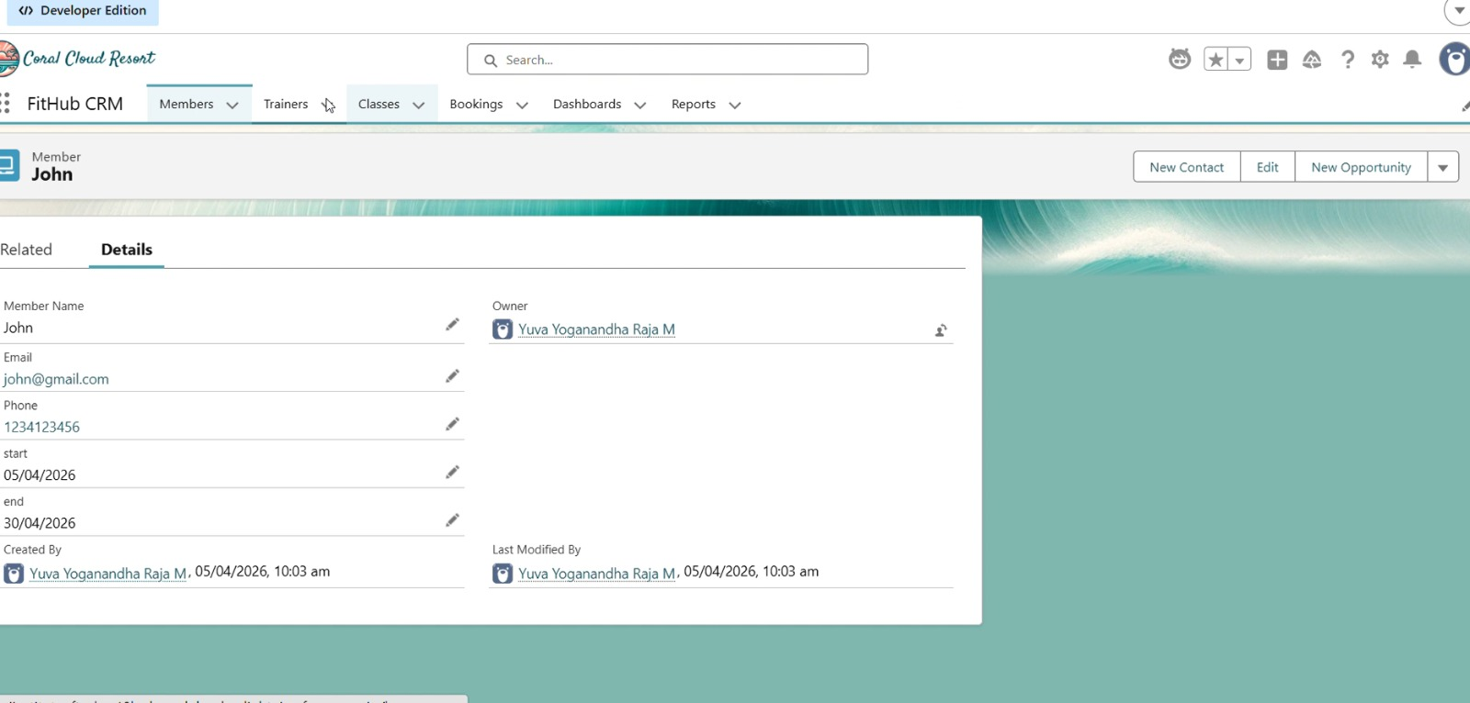
FitHub CRM: Saved Member record for 'John' showing all fields including Email, Phone, Start Date (05/04/2026), End Date (30/04/2026), Owner, and navigation bar with Members, Trainers, Classes, Bookings, Dashboards and Reports tabs

08 Reports Creation

Salesforce Reports were configured to provide management with data-driven insights into class attendance and member engagement. A custom report type was created to enable cross-object reporting.

Report Type | Classes with Bookings and Members — a custom report type that joins Class, Booking, and Member objects, enabling a single report to display data across all three entities.
Fields Used | Class Name, Booking Name, Booking Date, Booking Status, Member Name, Member Email, Membership Type — providing a complete view of who booked which class.
Filters Applied | Status = Confirmed, Date Range = Current Month — filtered to show only active confirmed bookings, eliminating noise from cancelled or pending records.
Format | Tabular Report with row-level detail, sorted by Class Name ascending. Designed for export and academic review of system data accuracy.

09 Dashboard Creation

A Salesforce Dashboard was created to visualize booking and attendance data in real time. Dashboards provide at-a-glance operational visibility for fitness center management.

Dashboard Setup | New dashboard created titled 'FitHub Booking Overview'. Configured with a 3-column layout for clean visual presentation. Set to refresh on login for current data.
Pie Chart Component | A Pie Chart widget was added sourcing data from the Bookings by Class report. The chart displays booking distribution across all active classes, allowing managers to identify popular and under-attended sessions.
Bar Chart Component | A Bar Chart was added showing member count by Membership Type (Basic, Standard, Premium), giving management a snapshot of the membership tier distribution.
Metric Component | A Metric tile was added displaying the total count of Confirmed Bookings this month, providing an instant KPI for current booking activity.

10 Testing

System Testing & Validation
Comprehensive testing was conducted across all configured components before final submission, ensuring the system behaves correctly under real-world usage scenarios.

T1 — Sample Records | Created test records for all four objects: 3 Members, 2 Trainers, 4 Classes, and 6 Bookings. Verified that all required field validations triggered correctly when fields were left empty.
T2 — Booking Flow | Tested the end-to-end booking process: member selected a class, Booking record created, Status set to Confirmed. Flow triggered as expected without manual intervention.
T3 — Email Notification | Verified that the Booking Confirmation Flow dispatched an email to the member's address upon booking creation. Checked email content for accuracy of class name, date, and member details.
T4 — Validation Rules | Attempted to enter a past date for Booking Date and an invalid email address on the Member object. Both validation rules fired correctly, blocking the save and displaying the configured error messages.
T5 — Report Accuracy | Ran the Classes with Bookings and Members report and cross-checked results against manually created records. All six bookings appeared correctly with accurate member and class data.

11 Screenshots Reference

The following screenshots are included throughout this document to provide visual evidence of the implemented system. Each screenshot is positioned adjacent to the relevant section for clarity.

Ref | Screenshot Title | Section
SS-1 | New Member Record Creation Form | Section 03 — Member Object
SS-2 | Saved Member Record Detail View | Section 07 — UI Configuration

12 Conclusion

Development Phase — Successfully Completed
The FitHub CRM system has been fully implemented on the Salesforce platform, with all planned objects, relationships, automation, and interfaces configured and validated.

The development phase successfully transformed the FitHub CRM planning document into a working, tested system. Four custom objects — Member, Trainer, Class, and Booking — were created with appropriate fields, lookup relationships, picklists, and validation rules. A Record-Triggered Flow automates booking confirmation emails, eliminating manual administrative effort.
The user interface was configured through Salesforce App Manager and Page Layout Editor, providing a clean Lightning Experience navigation bar with dedicated tabs for each object. Reports and dashboards deliver real-time operational visibility, while the testing phase confirmed that all components — validation rules, automation, and data relationships — function as designed.
This implementation demonstrates the practical application of Salesforce CRM for a real-world fitness center scenario. The system is production-ready for the defined scope and provides a solid foundation for future enhancements such as payment integration, mobile access, and multi-branch management.

FitHub CRM — Phase 2 Development Complete
System is configured, tested, and ready for academic submission and evaluation.

